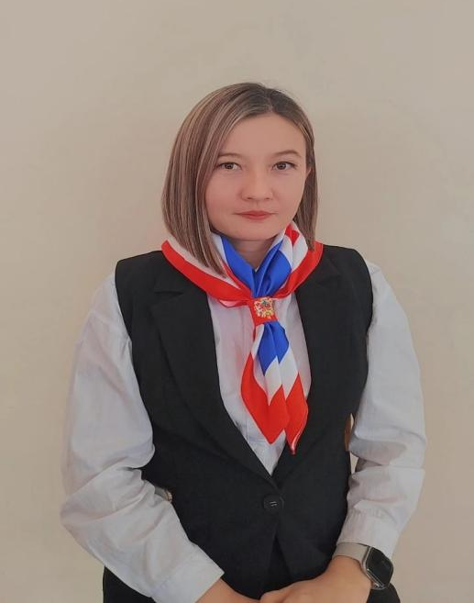
КУШЕНБАЕВА Айгуль Едигеевна,
№4 Балжан Бөлтірікова атындағы мектеп-лицейінің ағылшын тілі пәні мұғалімі.
Жамбыл облысы, Қордай ауданы

ADVANTAGES AND DISADVANTAGES OF KAZAKHSTAN'S INVOLVEMENT IN INTERNATIONAL EVENTS

Learning objectives | 9.1.2.1 use speaking and listening skills to provide feedback to classmates;  9.1.3.1 respect different points of view;  9.1.4.1 evaluate and respond constructively to feedback from other students.
Lesson objectives | Learners will be able to:  - Develop listeng and speaking skills.  - Enrich vocabulary on the topic of "International Events".  - Develop argumentation in English.
Instilling values of the program “Adal Azamat” | Unity and solidarity

Stages/  Time | Teachers actions | Students actions | Assessment | Resources
Beginning  5 min | Greeting.  Organization moment Ask about the weather.  What’s the weather like today?  -Do you like today’s weather?  I wish ... (W) students say wishes and compliments to each other  2. Brainstorming:  Warm-up : Word Association Chain  T says one word and Ss should quickly say other words that are connected with it. | Learners stand to the circle and say to each other positive desires.  Learners say words | Teacher controles the process, gives feedback and asks additional questions if it’s nessasery.  Teacher evaluate pupils with phrases like:  “Good job!  Well done!”  Formative Assessment
Middle  8 min | Video  After the watching the video ss should answer the questions.  1What is this video about?  2Why do people all over the world love football?  3Which football team have you supported?  4What was the level of the game?  5What was the benefits of participating in international game?  The teacher sets the lesson objectives and assess.criteria, letting students know what to anticipate from the lesson. | Learners answer the questions. | Excellent (2)  - All words matched correctly.  Good(1)  - Most words matched correctly; 1–2 Excellent (3)  - All key details correctly identified.  Good(2)  - Most details correct, minor omissions.
7 min | New Vocabulary  - Involvement – when someone takes part in an activity or event.  - Achievements – things that a person or country has done successfully.  - Championships – big sports competitions where the best teams or players compete.  - Benefits – good things or advantages that come from something.  - Reputation – what people think or say about someone or something.  - Development – the process of growing or improving in different ways.  Post-Listening Task  Individual Work.  Descriptor:Correctly identify all True and False statements.  Kazakhstan’s Involvement in International Events  Kazakhstan takes part in many international events such as sports competitions, cultural festivals, and political meetings. This involvement helps the country show its culture, achievements, and traditions to the world.  One of the main advantages is that it improves Kazakhstan’s image internationally. When Kazakhstan hosts or joins big events like EXPO, the Asian Games, or world championships, more people learn about the country. It also brings economic benefits, because tourists visit, hotels are full, and local businesses grow. In addition, such events give young people a chance to meet others, share ideas, and develop new skills.  However, there are also some disadvantages. Organizing or joining large international events can be very expensive. The government must spend a lot of money on preparation, security, and transport. Sometimes, these costs are higher than the benefits. Also, if the event is not well organized, it can harm the country’s reputation instead of improving it.  In conclusion, taking part in international events is important for Kazakhstan’s development, but it should be done carefully, with good planning and clear goals.  Group Work  The 1st group plus you will present your poster with Method Swot.  The 2nd group mines you will present your poster with Method Concept Map.  Your task is to write about the advantages and disadvantages that the international game between Kairat and Real Madrid could bring to our country."  Descriotor : work in groups  Identify the positive and negative aspects of the task | Learners do the task with Platform QUIZRISE.  Learners do the group work | Teacher evaluate pupils with phrases like:  “Good job!  Well done!”  Formative Assessment  Teacher evaluate pupils with phrases like:  “Good job!  Well done!”  Formative Assessment | Poster
End  5 min  Feedback | Conclusion Free Microphone  1What do you think is Kazakhstan’s participation in international events more positive or negative?  2Which international events do you think were most successful for Kazakhstan?  3Should Kazakhstan continue to host or join international events in the future?  4What do you think are the biggest challenges for Kazakhstan in organizing such events?  5 How can people in Kazakhstan help during international events?  Padlet Today I learned About …..  https://padlet.com/gulbanu2001q/reflection-q7swirg51193wegq | Ss Say their opinion  Ss use their stickers to show their knowledge according to the lesson{2;}

